ABC’s Inventory Management System

User Manual

Table of Contents

INTRODUCTION 4

What is the ABC Inventory Management App? 4

Learning Resources 5

Installation 5

System Requirements 5

For Windows OS 5

For Mac OS 5

Installing on Windows 5

Installing on a Mac 6

FIRST TIME LAUNCH 6

Sign In Account 6

OVERVIEW OF THE USER INTERFACE 8

Home Screen 8

Warehouse Staff 8

Store Staff 9

Search Product 10

Search Product code 10

Search Product Item code 11

View Product Item Location 12

Send Product Screen 13

Accept Product Screen 14

View Sending Transfers 14

View Transfer Detail 15

Manage Product Screen 16

Manage Product 16

Product Item Code Detail 17

Update Product Item Code Quantity 18

Add New Product 19

Add New Product Item 20

Edit Product Information 21

Update Product Information 22

Manage Staff Screen 23

Manage Staff 23

Add new Staff 24

Edit Staff Detail 25

Update Password 26

Generate Report 27

Generate Report Interface 27

View information of the Delivery 28

# **INTRODUCTION**

## What is the ABC Inventory Management App?

The ABC Inventory Management App is the most convenient way to get detailed and precise information about the stock movement and stock theft. This would also allow employees to look up current stock contents of the warehouse and each store and then request stock as required. Employees will also be able to send stock digitally i.e. automatically make an update to the database when stock is sent. Moreover, distribution of stock would also be much easier for the warehouse staff as they will know the quantity of each stock for each store.

The ABC Inventory Management App for desktop has the following key features:

* The store:
  + All store staffs will be provided with a store staff login account for ABC’s Inventory Management Application.
  + The store staffs can login to the ABC’s Inventory Management Application in the store’s computer.
  + The store staffs can search products by the product code to check its information.
  + If the information shows that the quantity of that product is 0 or low in stock, the store staff might choose the desirable quantity of that product and send a request to the warehouse. They may add other products to the same request too if desired.
  + The store staff can log out the account for securing information.
  + Application can be used in different stores if the number of store increases in the future, database update would allow new stores to be a part of the system.
  + Store staff search the code of the received parcel containing requested stock.
  + If the details in the system about the contents of the items in the parcel matches the actual contents, store staff can accept the items in the system by clicking the accept button. This will update the database.
  + The store staff can check the report of the previous transactions
* The warehouse where:
  + All warehouse staffs will be provided with a warehouse staff login account for ABC’s Inventory Management Application.
  + The warehouse staffs can login to the ABC’s Inventory Management Application in the warehouse computer.
  + The warehouse staffs can search the product by the product’s code to check its information.
  + The warehouse staff can add new products into the system.
  + The warehouse staff can also send parcel through the system by adding product code and quantity of each item in the parcel to be sent.
  + The warehouse staff can update the detailed information (except product code) in the system. Warehouse staff can also make changes to the number of stock available in both store and warehouse if stock discrepancies are found.
  + The warehouse staff can delete existing product that is no longer sold in the system.
  + The warehouse staff can check the report of the previous transactions.
  + The warehouse staff can add the new staff login account into the system.

# **Learning Resources**

ABC Developer Team provides help on how to use the ABC Inventory Management App for desktop. There’s the User Manual that you are reading now and an online support email: [abcsupportteam@gmail.com](mailto:abcsupportteam@gmail.com).

# **Installation**

## System Requirements

For using ABC Inventory Management System in your computer, please ensure that your computer meets the minimum system requirements for your operating system and hardware.

## For Windows OS

|  |  |
| --- | --- |
| **Component** | **Requirement** |
| Computer and processor | Minimum 1.6 GHz (or higher) (32-bit or 64-bit). |
| Memory | 2.0 GB RAM |
| Hard disk | 500MB of available disk space |
| Display | 1024 x 768 screen resolution |
| Graphics hardware | Minimum of 128 MB graphics memory |
| Operating system | Windows 10, Windows 8.1, Windows 8, or Windows 7 Service Pack 1 in 32-bit and 64-bit. For the best experience, use the latest version of any operating system. |

## For Mac OS

|  |  |
| --- | --- |
| **Component** | **Requirement** |
| Computer and processor | Minimum Intel processor, Core 2 Duo or higher |
| Memory | 2.0 GB RAM |
| Hard disk | 500MB of available disk space |
| Display | 1280 x 800 or higher resolution |
| Operating system | Mac OS X 10.11 El Capitan or later |

## Installing on Windows

The ABC Inventory Management App is installed by launching installer file that can be provided by ABC Developer Team.

1. Verify that your computer meets the minimum system requirements for your operating system and hardware.
2. After receiving the file from ABC Developer Team, you’ll see the .exe file. Double-click on it (it should be called, ‘ABCInventoryManagement.exe’). That will launch the Install Wizard which will guide you through the installation process.

## Installing on a Mac

The ABC Inventory Management App is installed by launching the installer file that can be provided by ABC Developer Team.

1. Verify that your computer meets the minimum system requirements for your operating system and hardware.
2. After receiving the file from ABC Developer Team, you’ll see the installer file, “ABCInventoryManagement.dmg”.
3. Double-click on the downloaded file to create the ABCInventoryManagement-Macinstaller package on your desktop. You will see a progress bar dialog indicating the extraction process. When complete, you may see a new removeable media icon on that will look similar to the image on the left.
4. If necessary, double-click on the ABCInventoryManagement-Macinstaller icon on your desktop to open a window containing the installer package.
5. Double-Click on the AbcInventoryManagement.pkg icon in the window that resembles a box. This will launch the Install Wizard which will guide you through the installation process.

*Figure 1: MacOS Installation*

# **FIRST TIME LAUNCH**

## Sign In Account

Launch the ABC Inventory Management App for desktop by double-clicking on the ABC Inventory Management App icon found on your Windows desktop or in the Applications folder on your Mac.

The account will be provided by the warehouse staff, depend on the working location, staff will have an appropriate account, enter username and password into the appropriate boxes and then click the **SIGN IN** button. The **CLEAR** button is used for reset the text boxes to be blank.

If staff has forgotten your password, they need to contact with the warehouse staff as soon as possible to reset the password.

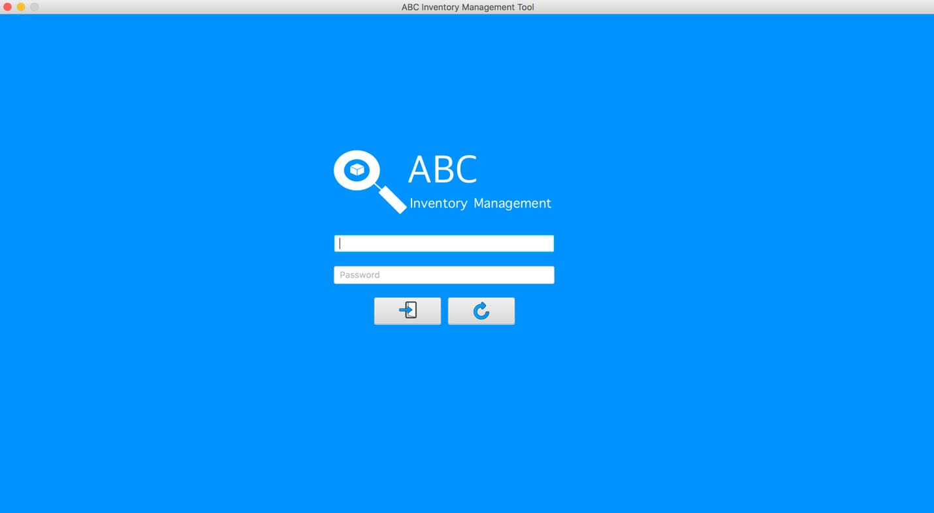

Sign In Button

Password

Username

Clear Button

*Figure 2: Login Interface*

# **OVERVIEW OF THE USER INTERFACE**

## Home Screen

### Warehouse Staff

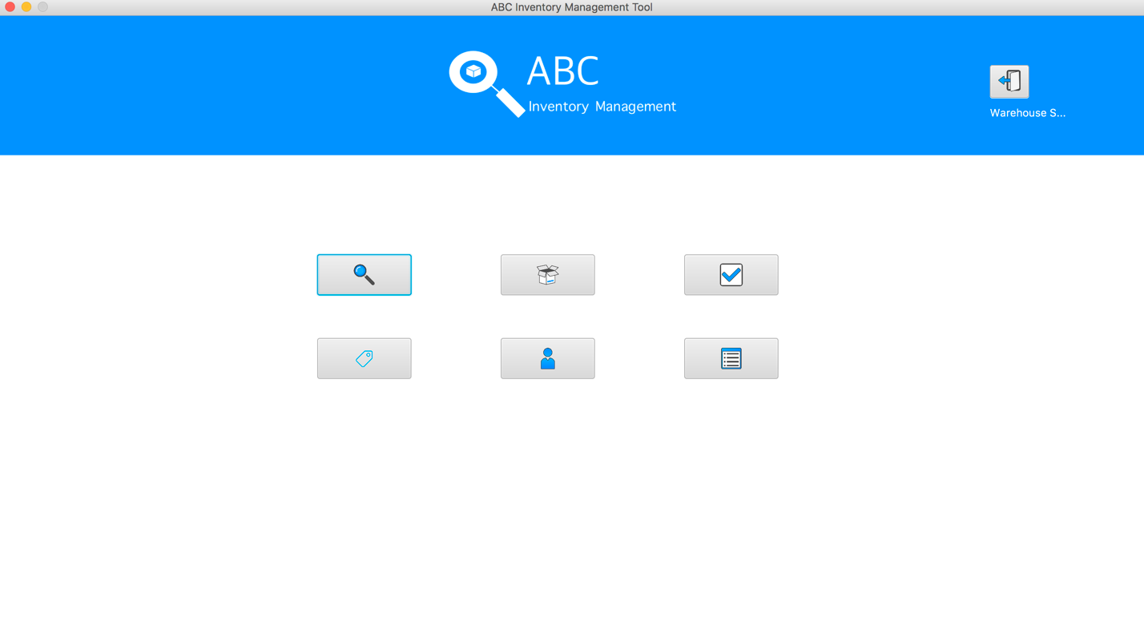*Figure 3: Warehouse staff Interface*

1

7

6

5

4

3

2

After logged in by the warehouse staff account, the application displays a home screen for user with 7 main functions as Figure 3:

1. Log out: located on the top-right corner in the screen, when user clicks on this button, the system logs out the current account and display the log in screen for signing in by other account. It also displays the role of current staff by the label under this button.
2. Search Product: users use this to search the details about the desired product in different locations by entering product code.
3. Send Product: this function is used for sending items from the location to another location indicating a delivery has been prompted.
4. Accept Product: this function is used for accepting the items that have been sent from another location indicating delivery has been accepted and database is updated.
5. Manage product: this function is used for add new products or product items, edit their detail information (quantity, description, name, etc. except product code) and remove products from the system.
6. Manage staff: this function is used for add and delete staff information including username and password.
7. Generate report: this function is used for generate a brief report containing sent location, destination location, delivery details (which consists the content details) when there is stock movement between two locations and filter the reports by in a specific timeframe.

### Store Staff

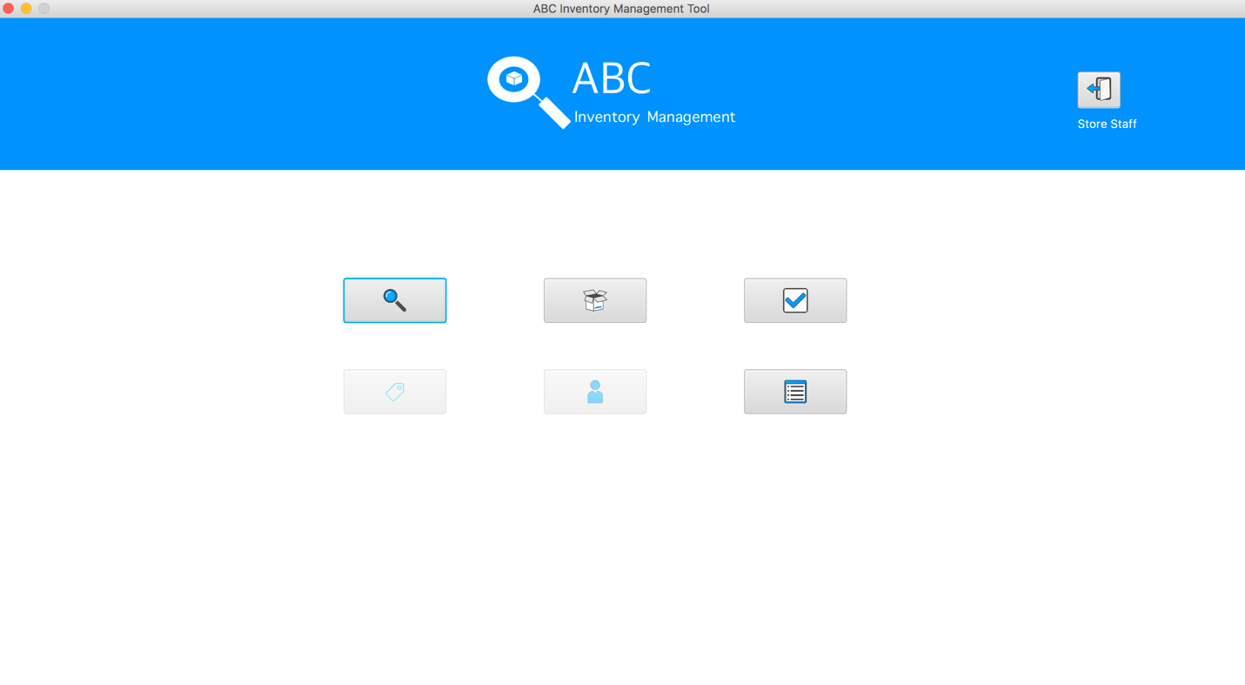*Figure 4: Store staff Interface*

5

2

3

4

1

After logged in by the store staff account, the application displays a home screen for user with only 5 main functions instead of 7 functions in Warehouse Staff home interface as Figure 4:

1. Log out: located on the top-right corner in the screen, when user clicks on this button, the system logs out the current account and display the log in screen for signing in by other account.
2. Search Product: users use this to search the details about the desired product in different locations by entering product code.
3. Send Product: this function is used for sending items from the location to another location indicating a delivery has been prompted.
4. Accept Product: this function is used for accepting the items that have been sent from another location indicating delivery has been accepted and database is updated.
5. Generate report: this function is used for generating a brief report containing sent location, destination location, delivery details (which consists the content details) when there is stock movement between two locations and filter the reports by in a specific timeframe.

## Search Product

### Search Product code

*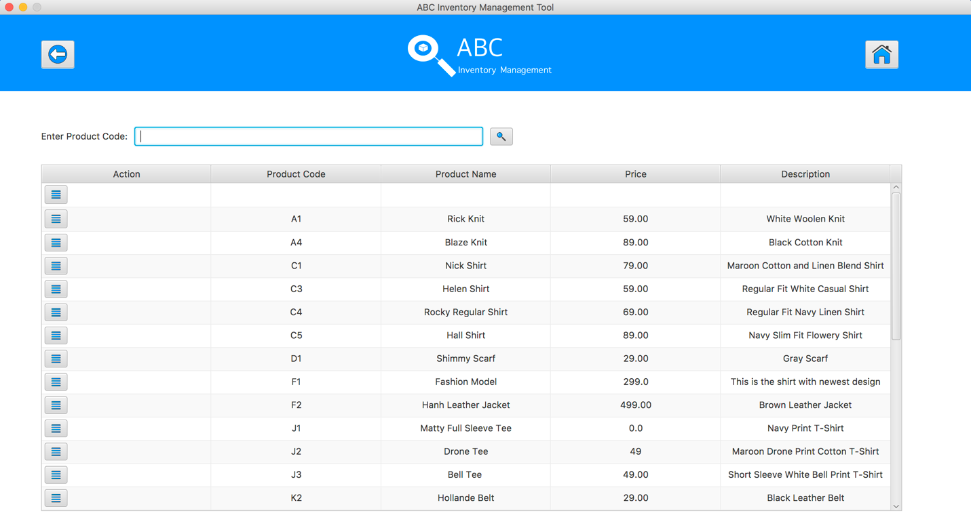Figure 4: Search Product Interface*

6

5

4

3

2

1

After selected Search Product Button from the home screen, system shows the Search Product Interface as can be seen in Figure 4:

1. Back Button: Go back to the home screen.
2. Home button: Go back to the home screen.
3. Product Code Text Field: User enters the desirable product code in this text field for searching a product.
4. Search button: After entered the product code in the text field, user hits enter keyboard or clicks on to this button to search a product.
5. “Detail” button: because 1 product contains different kind of product items (size s, m, xl, etc.) so user clicks on this button to see its product items.
6. Product information: This is the information of the product which includes product code, product name, price and description.

### Search Product Item code

*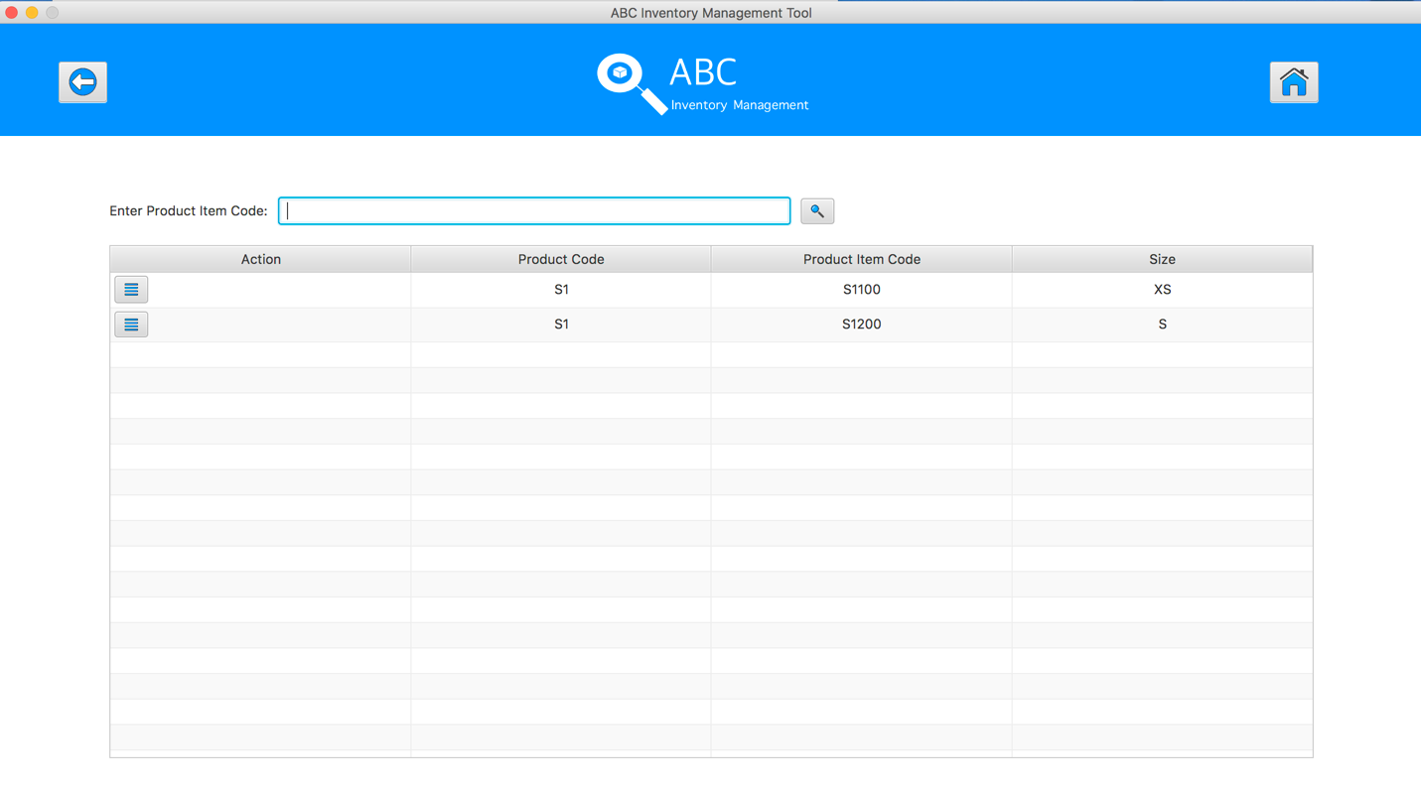Figure 5: Search Product Item Interface*

5

4

3

6

2

1

After hit the “Detail” button for a specific product, system shows the Search Product Item Interface which displays a list of product items in the selected product as can be seen in Figure 5:

1. Back Button: Go back to the Search Product screen.
2. Home button: Go back to the home screen.
3. Product Item Code Text Field: User enters the desirable product item code in this text field for searching a product item.
4. Search button: After entered the product item code in the text field, user hits enter keyboard or clicks on to this button to search a product item.
5. “Detail” button: because 1 product item can be stored in different locations so after hit this button, it shows the locations of this product item.
6. Product item information: This is the information of the product item which includes product code, product item code and size.

### View Product Item Location

*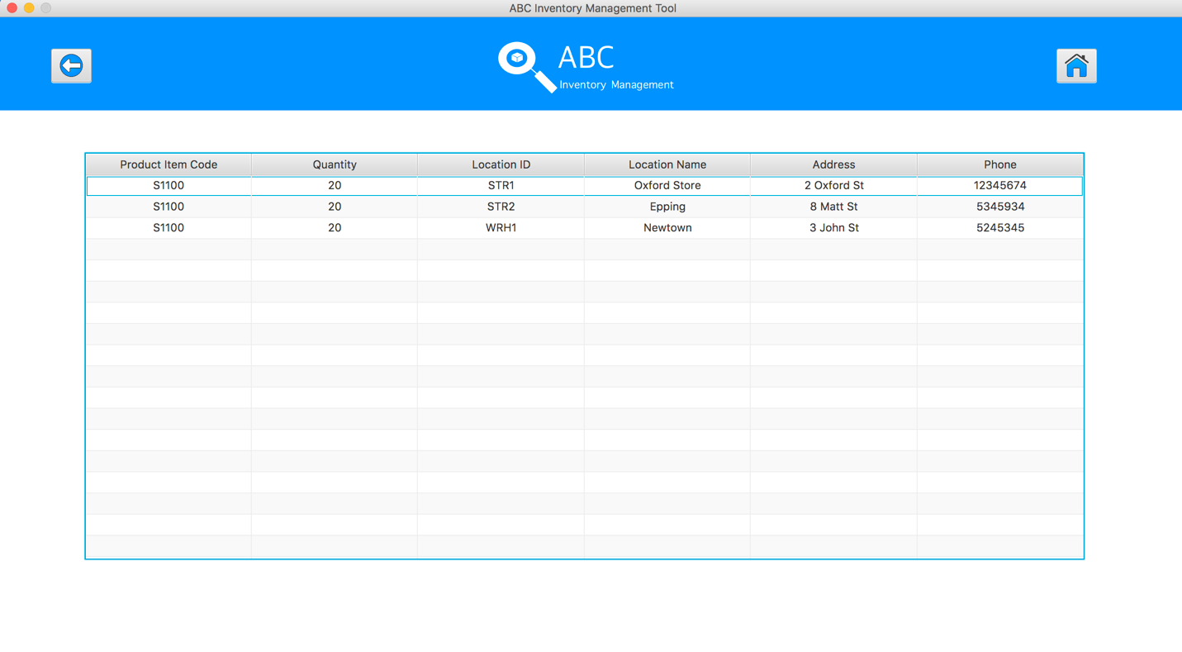Figure 6: View Product Item Location Interface*

3

2

1

After hit the “Detail” button for a specific product item, system shows the View Product Item Location Interface which displays a list of product items and the locations where store this product item as can be seen in Figure 6:

1. Back Button: Go back to the Search Product Item screen.
2. Home button: Go back to the home screen.
3. Product item information: This is the information of the product item which shows the location details of this product item.

## Send Product Screen

*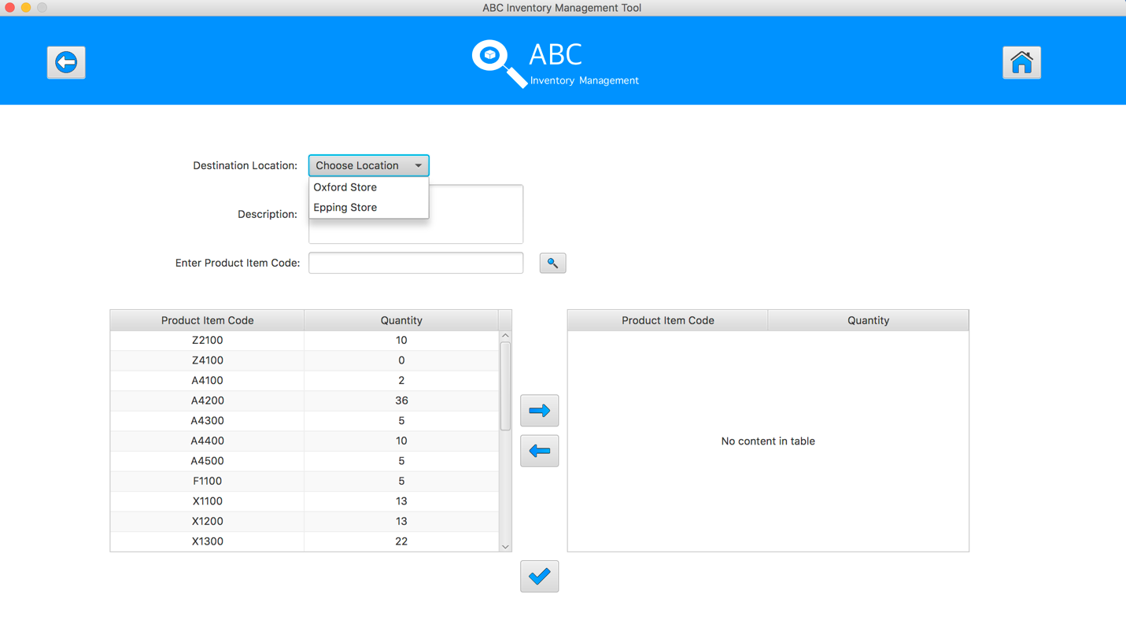Figure 7: Send Product Interface*

11

10

9

8

7

5

6

4

3

1

2

After selected Send Product Button from the home screen, system shows the Send Product Interface as can be seen in Figure 7:

1. Back Button: Go back to the Home screen.
2. Home button: Go back to the home screen.
3. Destination Location Dropbox: Staff selects the destination where the product will be sent from this drop-box list.
4. Description Text Area: Staff inputs the description for this transfer by typing in this box.
5. Product Code Text Field: Staff enters the desirable product code in this text field for searching a product in current location.
6. Search button: After entered the product code in the text field, user hits enter keyboard or clicks on to this button to search a product in current location.
7. Current product table: List of products and its quantity in current location.
8. Add to cart button: add the product from current product table to cart table for sending the product.
9. Remove from cart button: remove the selected product from the cart the table.
10. Cart table: the products which are added to this table will be the products for sending.
11. Send Product button: after hit this button, all the products will be sent to the destination, the quantity of the products which were sent in current location will be reduced appropriately.

## Accept Product Screen

### View Sending Transfers

*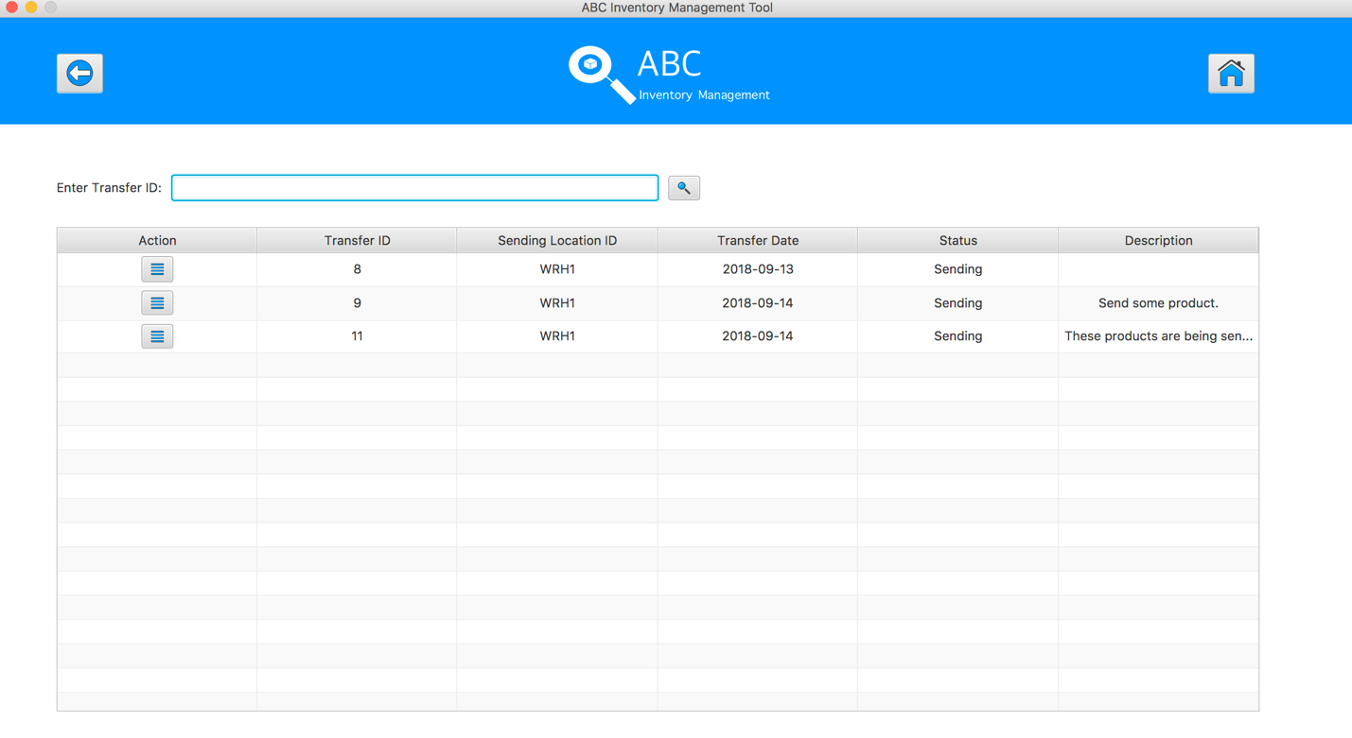Figure 8: View Sending Transfers Interface*

6

5

3

4

1

2

After selected Accept Product Button from the home screen, system shows the View Sending Transfer Interface as can be seen in Figure 8:

1. Back Button: Go back to the Home screen.
2. Home button: Go back to the Home screen.
3. Transfer ID Text Field: Staff enters the desirable transfer ID in this text field for searching a sending transfer.
4. Search button: After entered the transfer ID in the text field, user hits enter keyboard or clicks on to this button to search the desirable transfer.
5. Detail button: View the products which were sent in a specific transfer.
6. Transfer information: this part to show the information of transfers such as transfer id, sending location id, transfer date, status, description.

### View Transfer Detail

*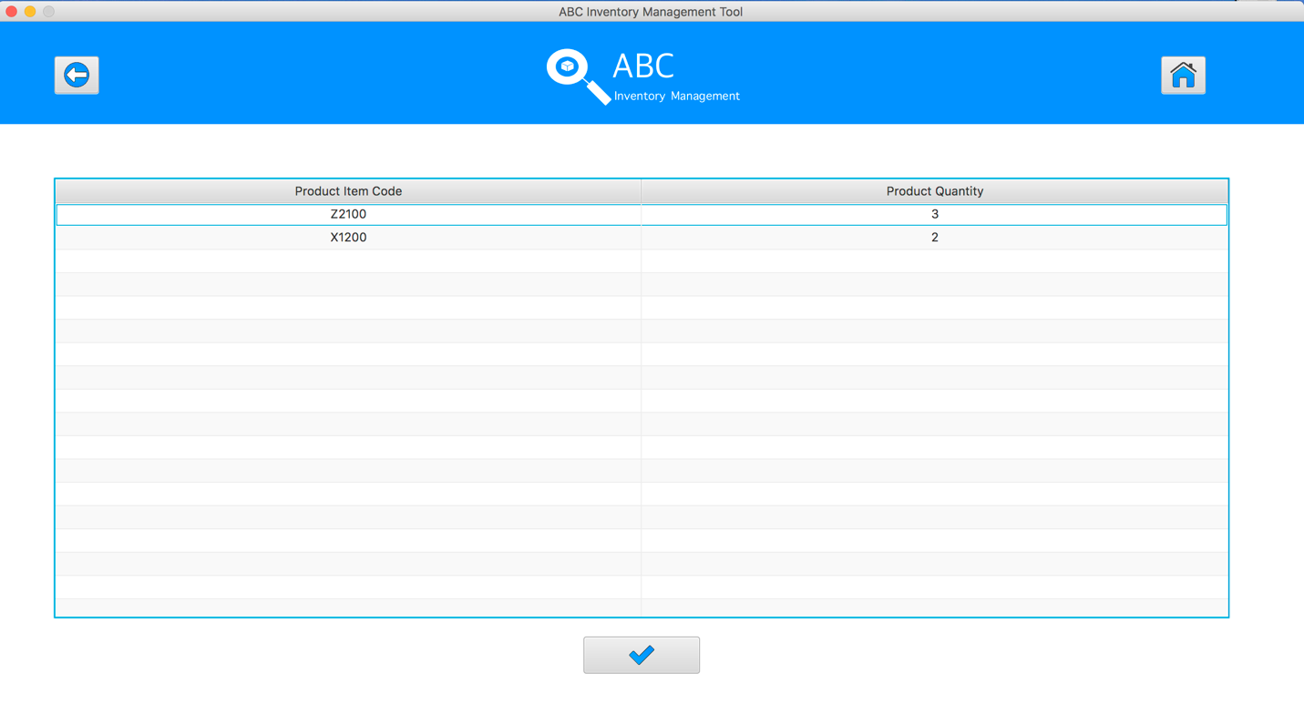Figure 9: View Transfer Detail Interface*

4

3

1

2

After selected Detail Button of a specific transfer, system shows the View Transfer Detail Interface which displays the products in this transfer as can be seen in Figure 9:

1. Back Button: Go back to the View Sending Transfer screen.
2. Home button: Go back to the Home screen.
3. Transfer Detail: this part shows the products information such as product item code and product quantity which were sent in this transfer
4. Accept button: after hitting this button, system remove this transfer from the accept transfer list and change its status to be” Accepted”, the quantity of those products what were accepted will be added to the accepted location.

## Manage Product Screen

### Manage Product

*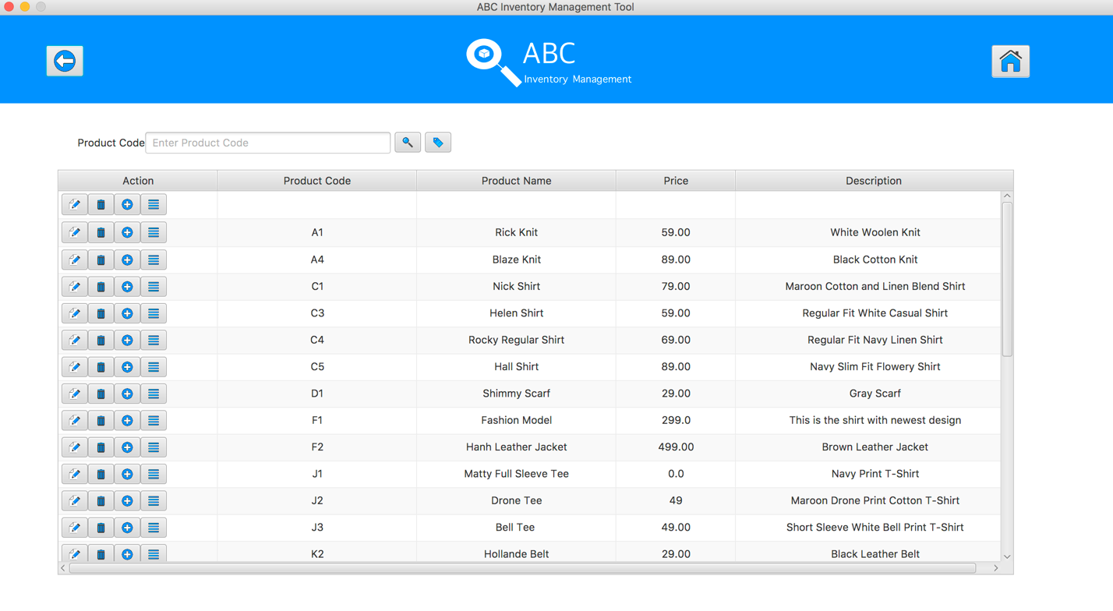Figure 10: Manage Product Interface*

7

5

4

3

6

1

2

After selected Manage Product Button from the home screen, system shows the Manage Product Interface as can be seen in Figure 10:

1. Back Button: Go back to the Home screen.
2. Home button: Go back to the Home screen.
3. Product Code Text Field: Staff enters the desirable product code in this text field for searching a product.
4. Search button: After entered the product code in the text field, user hits enter keyboard or clicks on to this button to search a product.
5. Add New Product button: after this button was pressed, system display the Add New Product interface to add a new product.
6. Action buttons: there are 4 buttons for each product with 4 functions: edit product information, delete product, add product items and view product items of specific product.
7. Transfer information: this part to show the information of transfers such as transfer id, sending location Product information: This is the information of the product which includes product code, product name, price and description.

### Product Item Code Detail

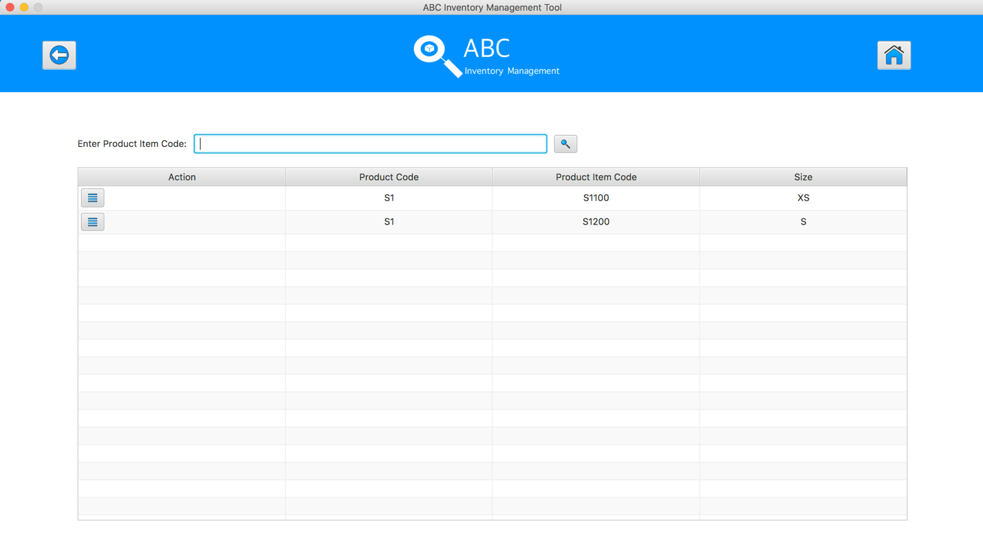

5

3

6

4

2

1

*Figure 11: Product Item Code Interface*

After staff clicks ‘View Product Item’ button from list of product detail, system displays the further information of the product.

1. Back Button: Go back to the Manage Product screen.
2. Home button: Go back to the Home screen.
3. Product Item Code Text Field: Staff enter product item code to search its data.
4. Search Button: Staff clicks to search the information of entered product item code.
5. View Button: Staff clicks to open further information of the product item code.
6. Product Item Code detail: Displays information of product item code. It contains product code, product item code and size.

### Update Product Item Code Quantity

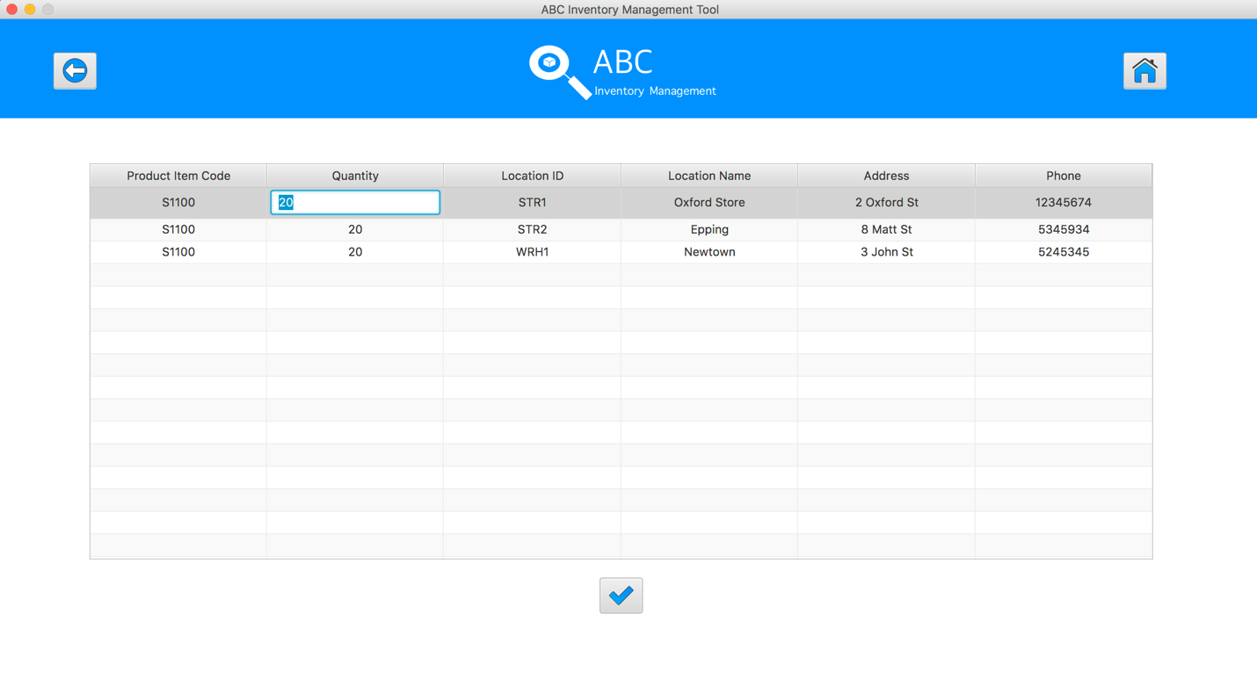

4

2

3

1

*Figure 12: Update product Item Code Quantity Interface*

After staff click ‘Action’ button in product item code as shown in figure 11, system displays a new window containing further information about the product item code.

1. Back Button: Go back to the Product Item Code screen.
2. Home button: Go back to the Home screen.
3. Product Item Code Details: Displays set of product item code. It contains product item code, quantity, location ID, location Name, address and phone number of the store.
4. Update Button: Updates the changes made in the quantity of the product item.

Staff can update the quantity of the product item just by double clicking the quantity number as shown in figure 12.

### Add New Product

*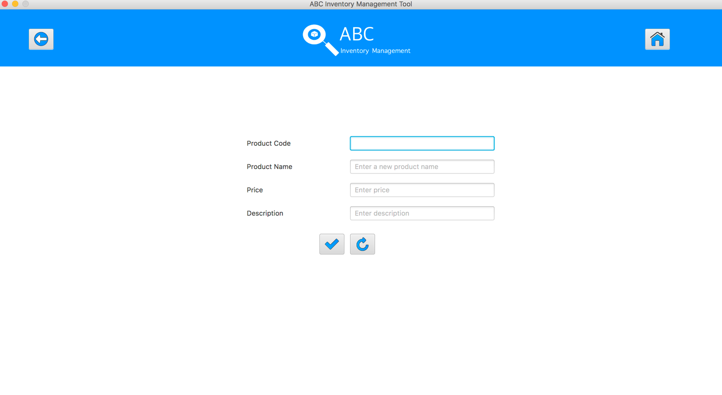Figure 13: Add New Product Interface*

8

7

6

5

4

3

1

2

After pressed Add New Product Button from the Manage Product screen, system shows the Add New Product Interface as can be seen in Figure 11:

1. Back Button: Go back to the Manage Product screen.
2. Home button: Go back to the Home screen.
3. Product Code Text Field: staff enters the new product code; the product code should be in the right format such as “S1”
4. Product Name Test Field: staff enters the product name for this new product.
5. Price Text Field: staff enters the price for this new product.
6. Description Text Field: staff enters the description about this new product.
7. Add Product Button: after filling all the new product information, staff clicks on this button to add this new product into the database.
8. Reset button: set all the text fields to be blank.

### Add New Product Item

*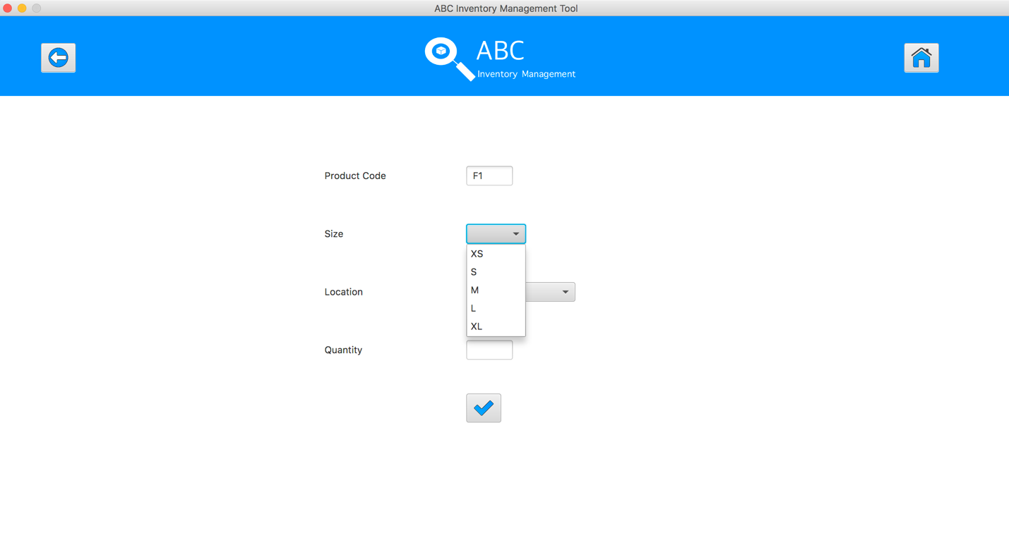Figure 14: Add New Product Item Interface*

6

5

4

3

7

1

2

After pressed Add New Product Item Button from the Manage Product screen, system shows the Add New Product Item Interface as can be seen in Figure 12:

1. Back Button: Go back to the Manage Product screen.
2. Home button: Go back to the Home screen.
3. Product Code Text Field: this text is set as the non-editable text field, so staff cannot edit this text field, it is used to let user know for which product they are they are adding the new product items.
4. Size Drop List: staff chooses the size for the new product item by selecting the size from this box. The new product item code will be generated base on selected size.
5. Location Drop List: staff chooses the location which stores this new product item.
6. Quantity: staff enters the number of quantity for this new product item.
7. Add Product Button: after filling all the new product item information, staff clicks on this button to add this new product item into the database.

### Edit Product Information

*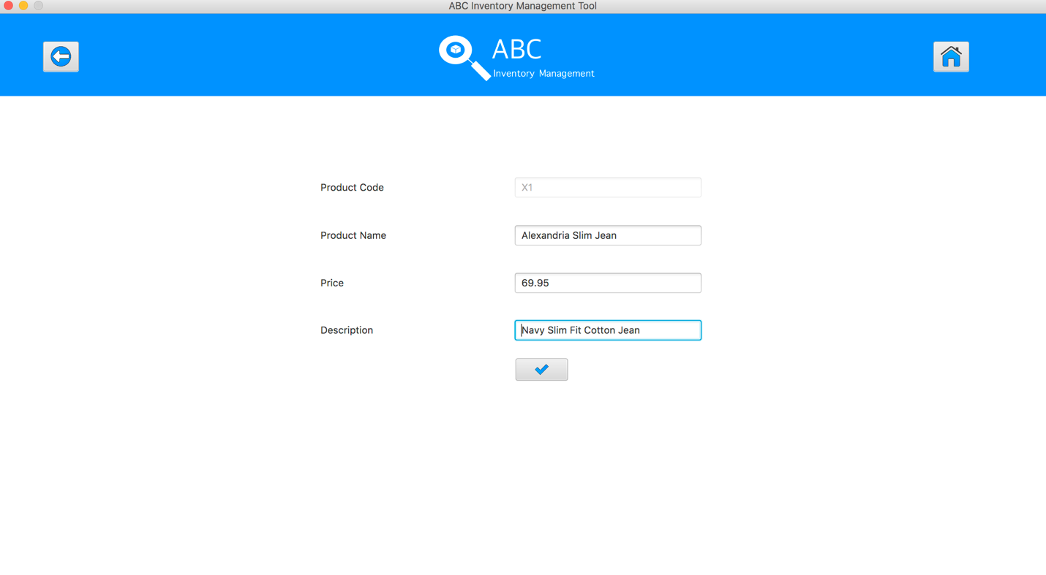Figure 15: Edit Product Information Interface*

7

6

5

4

3

1

2

After pressed Edit Product Button from the Manage Product screen, system shows Edit Product Information Interface as can be seen in Figure 13:

1. Back Button: Go back to the Manage Product screen.
2. Home button: Go back to the Home screen.
3. Product Code Text Field: this text is set as the non-editable text field, so staff cannot edit this text field, it is used to let user know for which product they are they are adding the new product items.
4. Product Name Text Field: Shows the original name of the product, this text is editable by staff. So, staff can click on the text field and update the name of the product.
5. Price Text Field: Shows the actual price of the particular item. It can be edited as staff desire.
6. Description Text Field: Displays the description of the product. The description of the product can be updated by the staff,
7. Add Product Button: after updating all the new product item information, staff clicks on this button to update the existing product item into the database.

### Update Product Information



7

6

5

4

3

2

1

Figure 16: Update Product Information Interface

Staff double clicks the description text field and changes the ‘Description’ to ‘Navy Slim Fit Cotton Jean’ to update the Product Information as shown in figure 14.

1. Back Button: Go back to the Manage Product screen.
2. Home button: Go back to the Home screen.
3. Product Code Text Field: this text is set as the non-editable text field, so staff cannot edit this text field, it is used to let user know for which product they are they are adding the new product items.
4. Product Name Text Field: Shows the original name of the product, this text is editable by staff. So, staff can click on the text field and update the name of the product.
5. Price Text Field: Shows the actual price of the particular item. It can be edited as staff desire.
6. Description Text Field: Displays the description of the product. The description of the product can be updated by the staff,
7. Add Product Button: after updating all the new product item information, staff clicks on this button to update the existing product item into the database.

## Manage Staff Screen

### Manage Staff

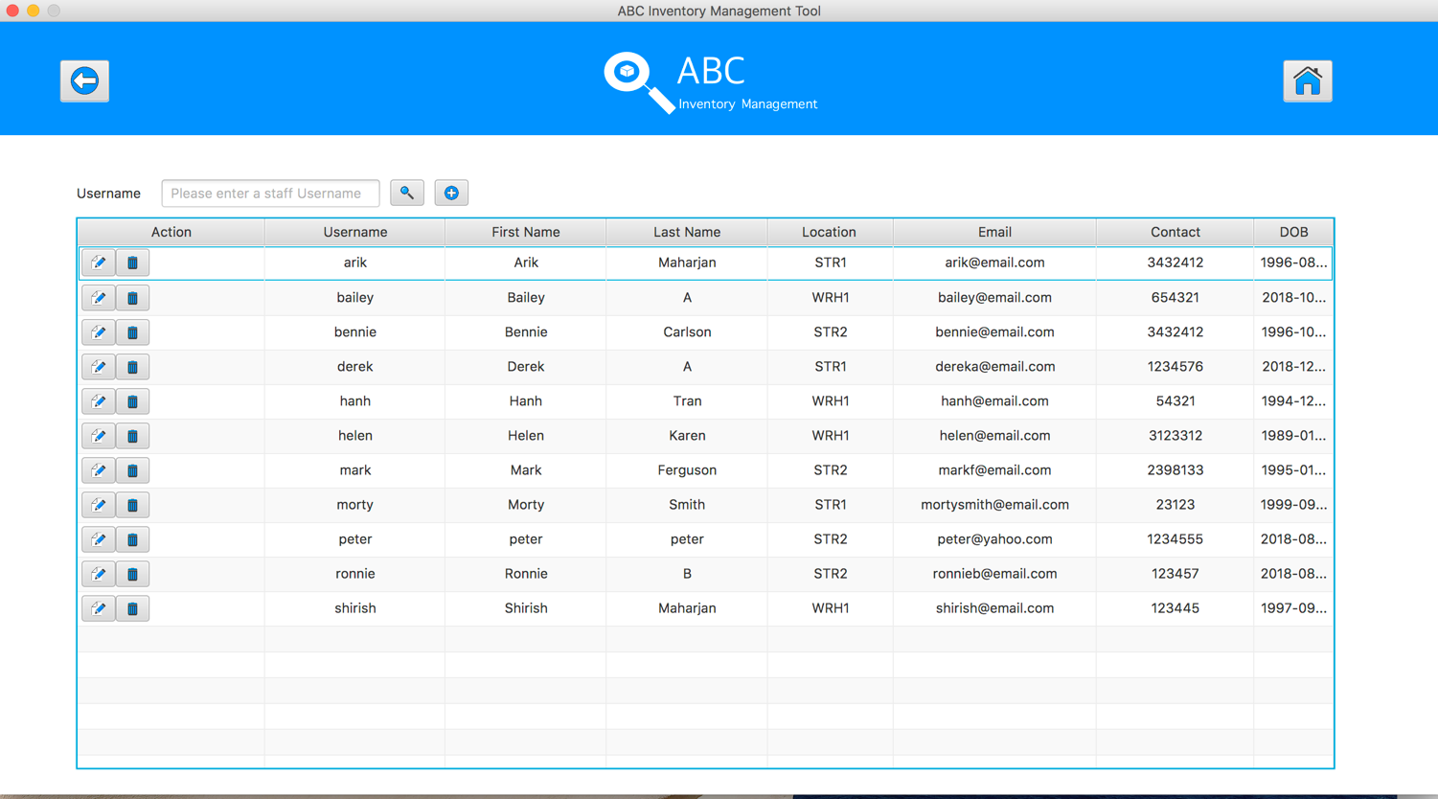

4

5

6

3

1

2

7

Figure 17: Manage Staff Interface

After selected Manage Staff button from home screen, system shows manage staff interface as represented above figure 15.

1. Back Button: Go back to the Home screen.
2. Home button: Go back to the Home screen.
3. Staff Name Text Field: Staff enters the desirable name of the staff member in this text field for searching their account.
4. Search button: After entered the staff name in the text field, user hits enter keyboard or clicks on to this button to search an account.
5. Add New Staff button: after this button was pressed, system display the Add New Staff interface to add a new Staff into the database.
6. Action buttons: there are 2 buttons for each Staff with 2 functions: edit Staff information, delete product, delete Staff of specific product.
7. Transfer information: this part to show the information of the staff such as username, First Name, Last Name, Location, Email, Contact and DOB.

### Add new Staff

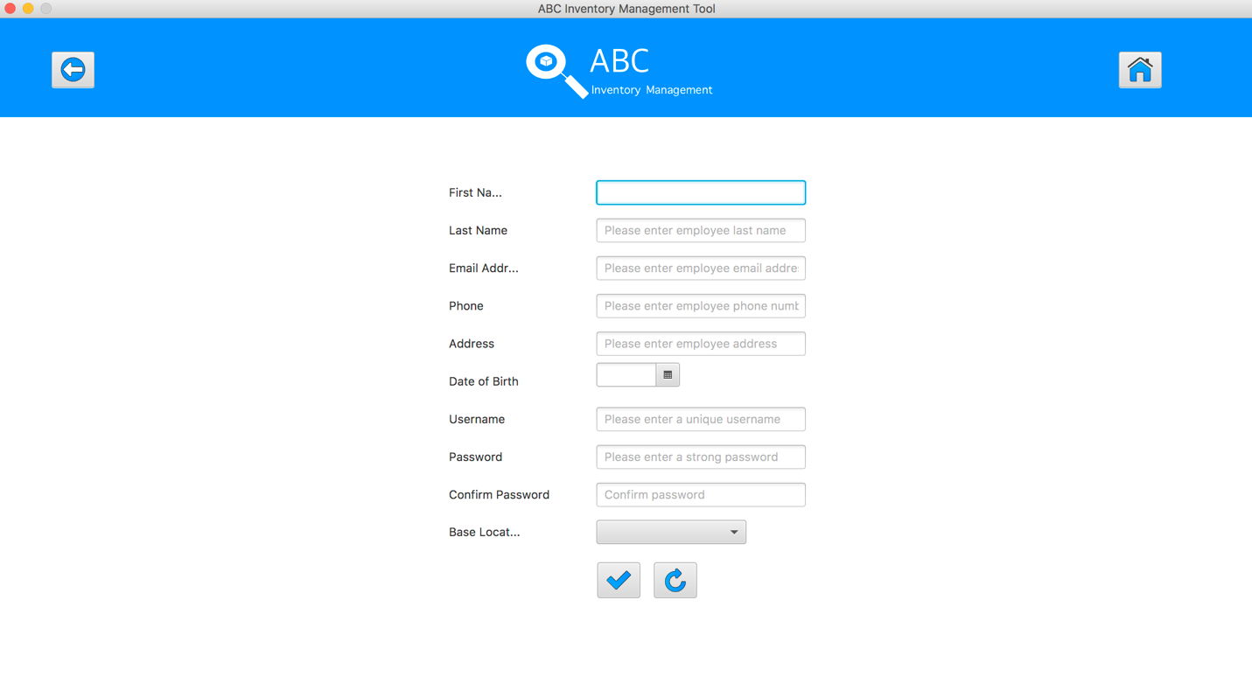

14

13

11

12

10

9

8

7

6

5

4

3

2

1

*Figure 18: Add New Staff Interface*

After clicking ‘Add Staff’ button, system shows the following interface in figure 15. Staff enters all each detail related to the new staff.

1. Back Button: Go back to the Manage Staff screen.
2. Home button: Go back to the Home screen.
3. First Name Text Field: Staff enters the first name of the new staff.
4. Last Named Text Field: Staff enters the last name of the new staff.
5. Email Address Text Field: enters email address.
6. Phone Text Field: staff enters phone number of the new staff.
7. Address Text Field: staff enters Residential address of the new staff.
8. Date of Birth Text Field: staff enters date if birth of new staff.
9. Username Text Field: staff enters username of new staff. Username given must be unique for every staff of the store.
10. Password Text Field: staff enters password for new staff. Staff enters a general password at first, then staff will manually change it later.
11. Confirm Password Text Field: Re-Enters password.
12. Base Location: Choose the location of the store allocated to the new staff.
13. Add New Staff Button: After filling all the criteria shown in figure 15, staff clicks the button to upload all data of the new staff in the database.

### Edit Staff Detail

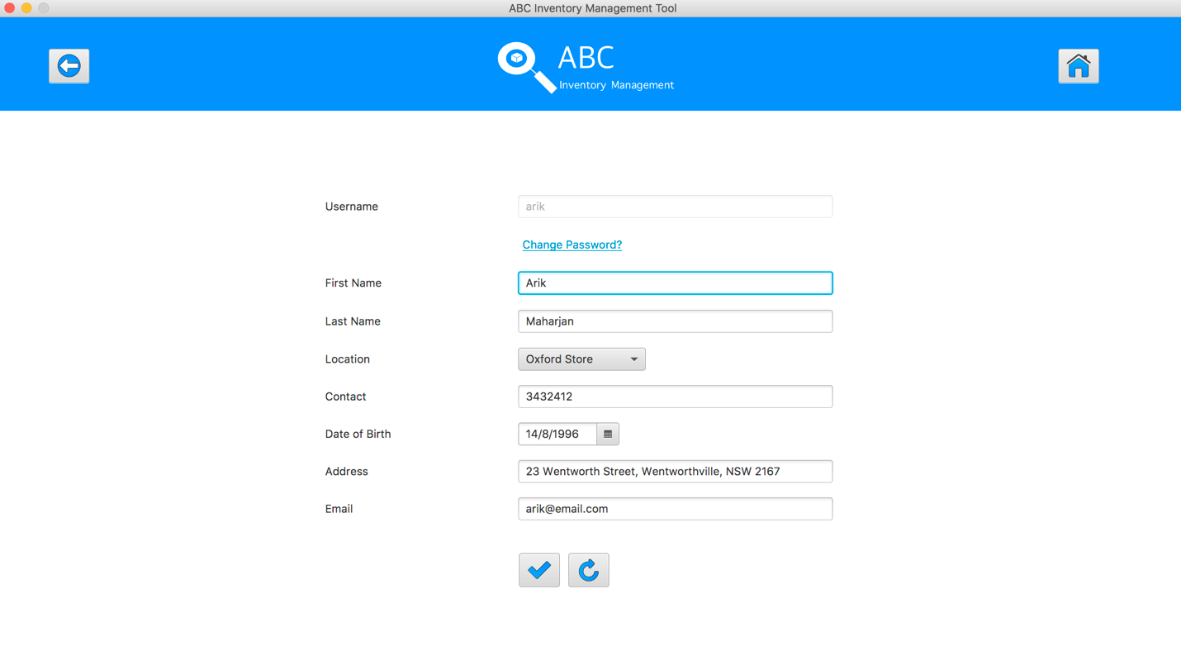

13

12

11

7

8

6

5

10

3

2

9

4

1

*Figure 19: Edit Staff Details Interface*

After clicking ‘Update Staff” button in list of staff detail, system displays the detail of the staff as in figure 16. The details are updated clicking to the desired text field by the staff.

1. Back Button: Go back to the Manage Staff screen.
2. Home button: Go back to the Home screen.
3. Username Text Field: Shows username of the staff. This field is not editable as the username must be kept unique at all times.
4. Change password button: Staff can click this text to change the current password of staff.
5. First Name Text Field: Shows first name of staff.
6. Last Name Text Field: Shows last name of staff.
7. Location Choice Box: Displays Location that staff works in.
8. Contact Text Field: Displays Contact Detail of staff.
9. Date of Birth Text Field: Displays DOB of staff.
10. Address Text Field: Displays name of address of staff.
11. Email Text Field: Displays email of staff.
12. Update Staff Button: After changing necessary information about the staff, this button is clicked to update the information in the database.
13. Reset Button: Any changes made with the account is set back to original one.

### Update Password

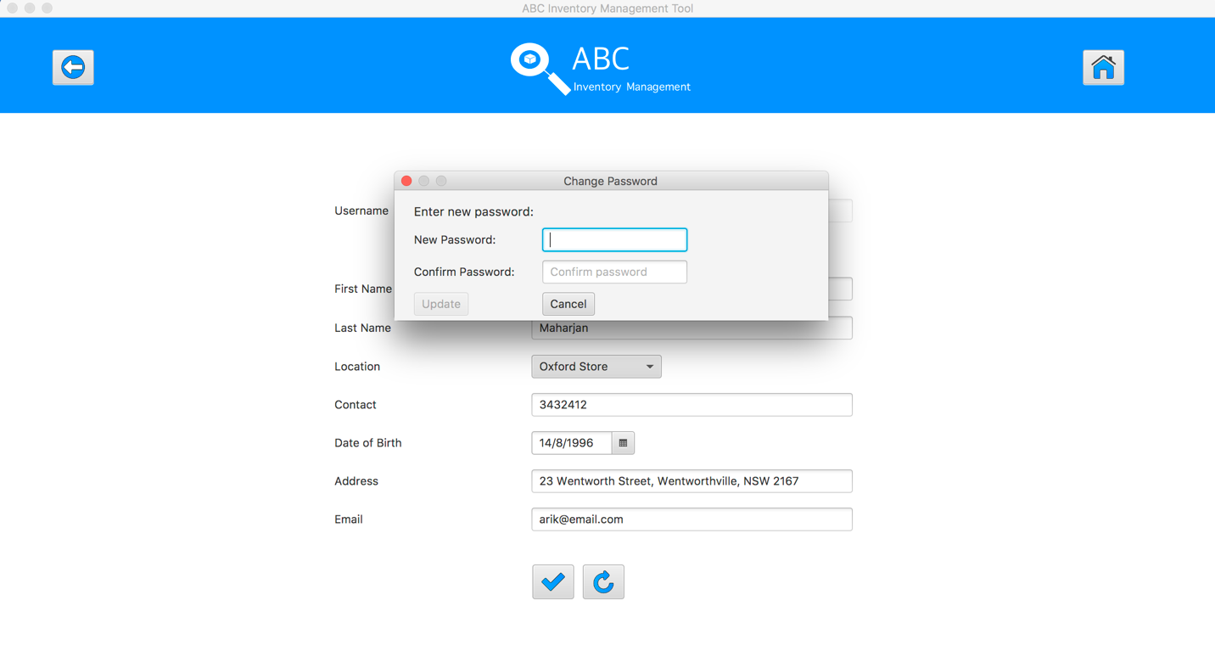

6

5

4

3

2

1

*Figure 20: Change Password Interface*

After clicking the ‘Change Password’ button in Edit staff, a small window is prompt which asks the staff to enter new password for the account.

1. Back Button: Go back to the Manage Staff screen. It is disabled during this action.
2. Home button: Go back to the Home screen. It is disabled during this action.
3. New Password Text Field: Staff enters new password for the account.
4. Confirm Password Text Field: Re- enters the new password for the account
5. Update Button: After entering password in both text fields, if the password matches, staff is able to click ‘Update’ button.
6. Cancel Button: If staff decide not to update password, click ‘cancel’ button to go back to previous window.

## Generate Report

4

3

### Generate Report Interface

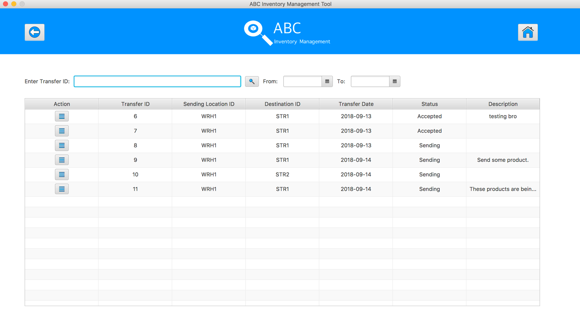

8

7

4

6

2

1

*Figure 21: Generate Report Interface*

After Staff clicks ‘Generate Report’ button from home page, system displays the list of transfers of product as shown in figure 18 above.

1. Back Button: Go back to the Home screen.
2. Home button: Go back to the Home screen.
3. Search Button: staff clicks to search for the transfer with Transfer ID.
4. Delivery from: Staff chooses the date that transfers occurred from.
5. Delivery till: Staff chooses the date that transfer occurred till.
6. Transfer ID Text Field: Staff enters transfer ID of the delivery.
7. Action Button: Staff clicks the button to show the details of the selected transfer’s delivery information.
8. Transfer Detail: Displays the general information of the delivery. Its contains Transfer ID, Sending Location, Destination Location, Transfer Date, Status and Description of delivery.

### View information of the Delivery

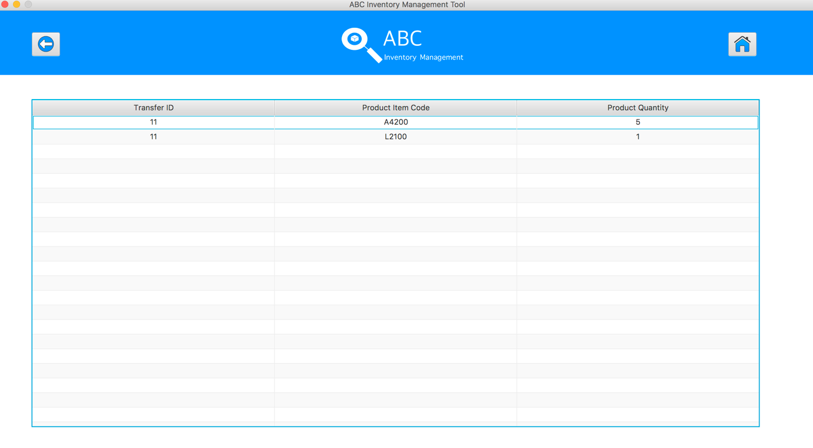

1

3

2

*Figure 22: Delivery Information Interface*

After staff clicks in the ‘Action’ button from the list, system shows the full details of the product item code and the number of product sent.

1. Back Button: Go back to the Generate report screen.
2. Home button: Go back to the Home screen.
3. Report: Displays the information about the transfer. Its shows the information as Transfer ID, Product Item Code and Product Quantity as shown in figure 19.